Purchase Recommendation
Name of Student
Institution Affiliation

Purchasing Recommendation
Why Own An IPad?
An iPad
The world has come to an era where technology is on the increase, every young and grown adult needs to own a smartphone. A smartphone is an electronic gadget used to surf the internet, receive and send emails, listen to music, watch videos, play games as well as access electronic books. Well, an iPad falls under the category of tablets, which are also smartphones, only that it has high operating power than regular tablets (Allen, 2015). Apple prides itself as the manufacturing company due to the top sells that the product generates since its inception. The slate computer is neither an iPhone nor a Mac but a product that contains features of both electronic gadgets. Even though an IPad uses the same operating system as that of an iPod touch, which makes the compatibility of their applications possible, it does not lie under the category of iPhone touch products. Thus, an IPad is a tablet that has high operating system and can operate function just like some personal computers.
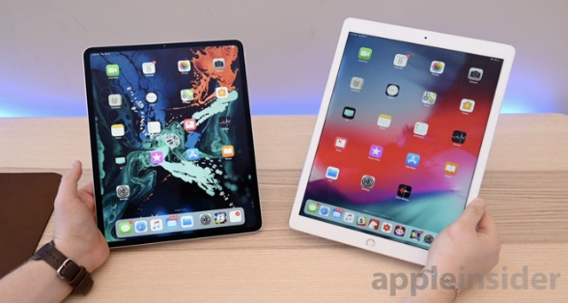
2018 iPad Pro 3rd gen (left) and 2nd gen (right)
Mac OS X applications are not run by the iPad, ruling it out as a Mac. However, the iOS present in an iPad is derived from a Mac OS X. Accessories that come along with the product are, external keyboards that are wireless and Bluetooth enabled. Compatible Mac or Windows personal computer can synchronize an iPad model (Allen, 2015). Production of creative, realistic content such as videos, photos, and music on iPad Pro products elevates iPads above other traditional computers. Apple's tablets such as iPad Pro that come in sizes of 12.9 or 11 inch contain features that are of high technology power that those of some laptops. Unique features such as: the high resolution power of the screen that ranges from 1024 by 768 pixels to 132 pixels per inch and the finger print-resistant coating makes the Apple tablet Model appeasing to buyers. An Apple iPad has an inbuilt wireless connectivity mode that include Bluetooth 2.1 with EDR technology.
Apple made the computer model with the intention of creating portable computers that are easy to carry around with ease of access. The built in rechargeable lithium-polymer battery can withstand long hours of about ten hours of internet surfing and video calls making it effective for working outside the confinement of an office. Learners can use the machine to surf the internet for academic research purposes, distance learning, electronic reading as well as email operations. Besides, any person who can use a smartphone can as well manage to use an iPad that will serve its purpose of communication and fetching of data from credible browsers. Executives as well make use of the iPad in fetching information in their fields of work, its portability compared to a desktop makes it suitable for use by executives. For music lovers, the Apple iPad is ideal for their use, because it supports protected AAC from iTunes stores and it has audible formats that range from 2 to 4. It is evident that an Apple iPad is an essential and useful tool.
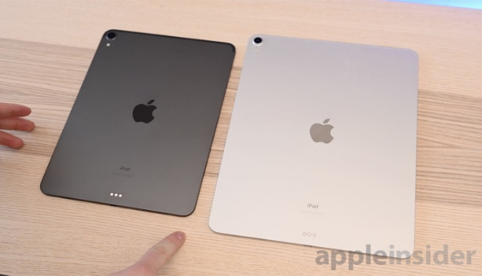 2018 iPad Pro new exteriors
Where to Purchase and the Pricing Cost
Online shops have tried to catch up with the rise in technology by providing services at the touch of a smartphone via the internet. Amazon, global edge solutions are just some of the online platforms where one can purchase an iPad. Buying from the Apple phone collection stalls can as well be convenient. Apple's iPad such as the recently released 9.7 inch iPad for prices as low as $330. Pricing of any iPad starts from $499 for a 16GB model, a 32GB iPad model goes at $599, while the 64GB iPad version is sold at $699. A stylus that bought separately at the cost of $100 is compatible with the 2018 9.7 inch tablet. The $330 pricing is very low compared to the iPad pro tablets that cost over $500. Because Android tablets cost a fortune more than the 9.7 inch iPad, they lack better library applications as well as the efficient accessory support system.
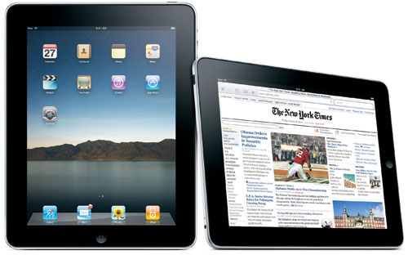
Photo Credit: Apple, Inc. (Original iPad with Keyboard/Regular Dock)
Purchasing Recommendations of an iPad
Purchasing power solely depends on the needs of the customers, the use of the machine as well as the amount of money available. The customer opts to buy any of the iPad models since they are all under one brand which Apple. For one to avoid disappoints that may arise from purchasing that wrong places, where the pricing may be high than the usual cost, it is advisable to do various window shopping before settling on where to buy. I would personally recommend direct purchasing from the company and credible online shops such as Amazon; this will guarantee a proper warrant in cases where the slate computer gets faulty.
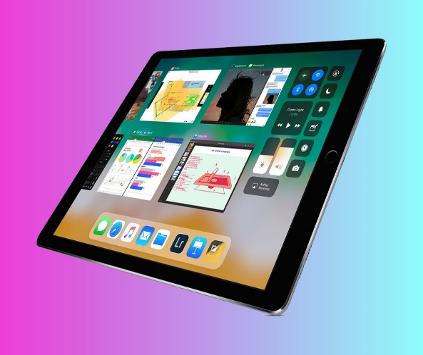
Apple's iOS 11 update was more geared towards the iPad than any previous release of iOS.
Despite the overall good qualities of the tablet, they appear according to suitability and degree of excellence. A 2018 9.7-inch iPad is known for its fast processor, enabled use of a pencil, sharp screen as well as fair pricing of $330. The 9.7 inch iPad highly sold due to its distinguishable features and affordable pricing. Most artists, architects, Engineers and all other professionals that entail drawing would go for the 2018 9.7 inch iPad, because of the Apple pencil stylus that comes as an accessory when purchasing. Other Apple iPad brands include iPad Pro which is 11 and 12.9 inches and Mid-size iPad pro that is 10.5 inches.
I would recommend 2018, 9.7-inch iPad for scholars, professionals as well as executives due to its size that is conveniently portable and light in weight. The aluminum build used in its makings gives it an old fashioned appearance, but the durability of the build is worthy of making the purchase. Besides, the 9.7-inch tablet is advantageous in that; and with a durable, slick aluminum design (David, 2015). A touch identification for security is present in the tablet, it also supports the stylus Apple pencil, and moreover, its intelligent operating system is at 11. The powerful processor of A10 that enable fast operations distinguishes it from ordinary computers in the market. Hopefully a technique to enable multiple running of applications will be designed to enhance the efficiency of the slate computer.
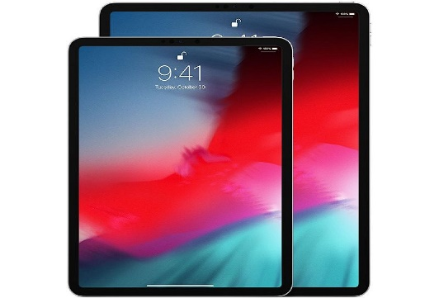
Instead of a Lightning port, the new iPad Pro adopts a USB-C port that lets it connect to USB-C accessories including 4K and 5K displays. The USB-C port on the iPad can also be used to charge accessories like the iPhone and Apple Watch.
Brands to Avoid
Though all iPad is from the Apple Company, it is not a guarantee that any slate computer is suitable and efficient for use. IPad 1-4, iPad Mini 1-3, and iPad Air are among the few iPads to avoid. Newer versions are likely to work better than these outdated versions of iPads. Outdated versions tend to be very slow compared to android phones or computers since the software systems of the iPads are no longer updated (David, 2015). When in need to get a tablet for your kid's games, an iPad Air will be inconvenient due to its high pricing that is not worth for a single purpose. Resolution power of the screen is meager in iPads such as the Mini1 and iPad 1-2. Counterfeits products are on the increase and one can easily get carried away to purchasing them. For credible and genuine iPad models, one has to get them through reliable phone stores. The risk of getting an older non-functional iPad is higher than that of saving for the latest version of a high processor iPad.

Recommendation Sources
Jeffrey Van Camp Gear, article: ‘Which iPads you should buy and the ones to avoid' written on 11, 14, 18 was useful in providing the information on which iPad is not good to purchase. The writer mentions the old iPad by their models. He explains as to why the iPads are not suitable for purchasing. Besides, Jeffrey gives an elaborate guideline of prices, models and their processing power to readers or customers on the model of iPads to buy.
Global edge solutions, as well as Amazon, provide an online platform in which potential customers can view photos of the iPads and make their choice of purchasing from physical judgment. The two sites as well helped in providing the price range factor for the products.
Business Insider written by Malarie Gokey on 11, 14, 18 helped in giving the various iPad models. Features of each iPad according to size and quality are present in the article. The Latest iPad 2018 that is 9.7 inches merged best iPad in the section of the article.
Every iPad.com retrieved from EveryMac.com published in 2018, provided an elaborated explanation on what an iPad is, as well as the features present in an iPad. Elaborate uses of an iPad are on the site. Besides, the site gives information on the target market for each iPad model.
An article on Computers and smartphones and Tablets written by Allen, 2015 gives a sense of direction on which computer device to buy. The author gives the Apple iPad as an option to a good smartphone device.
https://appleinsider.com/articles/18/11/08/these-are-the-best-29-features-of-apples-2018-ipad-pro. http://://www.pocket-lint.com/tablets/nhttpsews/apple/141854-7-apple-ipad-features-for-students-when-ios-11-arrives. The two sites provided the image to aid in giving a visual acquaintance of the Apple iPads.

